Configuring the LK-P12 using the Informs Mobile Label Printer Utility
NOTES AND PREREQUISITES:
- All downloads and instructions can be obtained from the Informs LK-P12 Support page: http://www.informsinc.com/lkp12support/
- Install INFORMS LK-P12Z Printer Driver-1.00 driver and ensure the printer exists in the Windows Printer and Faxes (WIN XP) or the Devices and Printers (WIN 7) folder.
- At power up verify printer firmware is at S/W VER v1.14 ZPL or higher. If it is not at this firmware level, update the firmware.

- Load label stock in the printer and turn it on.
- Launch the Mobile Label Printer Utility. If prompted, allow the Informs Mobile Label Printer Utility to make changes to the computer.
- In the Printer Connection Settings section choose the USB Port type and click the Open Port button. If the connection is successful the Open Port button will be grayed out and the Close Port button will become active.
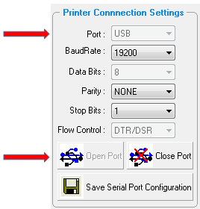

- [OPTIONAL] If the printer does not display ZPL in the initial boot screen complete this step. In the Emulation Settings section ensure the printer emulation is set to ZPL. If it is not click the Set ZPL button.
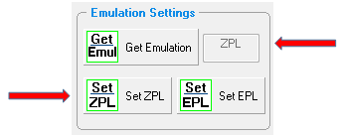
- [OPTIONAL] If the printer does not feed the label to the tear off position when the feed button is pressed complete this step. In the Label Media Settings section Click Set Gap for labels with Gaps or Set Black Mark for label with black marks. Once selected the button should become grayed out.
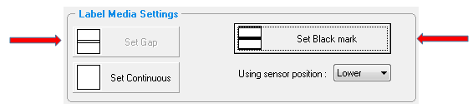
- [OPTIONAL] if increased darkness is required, select the advanced options button to increase the density setting. A setting of 40 is usually sufficient. Be sure to save the setting before existing the screen.
NOTE: you must have the latest version of firmware and Mobile Label Printer Utility for this setting to be available.

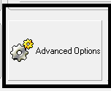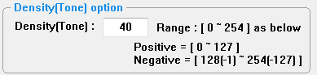

- [OPTIONAL] If you want the printer to never power off due to inactivity, set the Power Save Mode to Power Save Off. Although this consumes more power the printer battery will still last an entire shift and there will be no issues with the printer going to sleep. Click Save Power Save Mode when settings are complete.
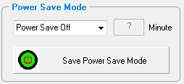

- [Bluetooth ONLY] In the Bluetooth Settings section click the Get Bluetooth Information button. The printer information will populate the fields. You can:
- Assign a name to the printer in the Bluetooth device name section.
- Assign a PIN to the printer in the PIN Code Information section. After the PIN Code is entered click the Save Bluetooth PIN Code button. NOTE: The PIN value must be numeric and at least 4 digits.
- Ensure that the printer is discoverable in the Discoverable Mode Information section.
If a PIN is assigned be sure to click the Save Bluetooth PIN Code button. Once the desired changes have been made you must click the Set Bluetooth Information button. The printer will beep and the Set Bluetooth Information button will become grayed out.
To Exit click Close Port in the Port Connection Settings section then click Exit.
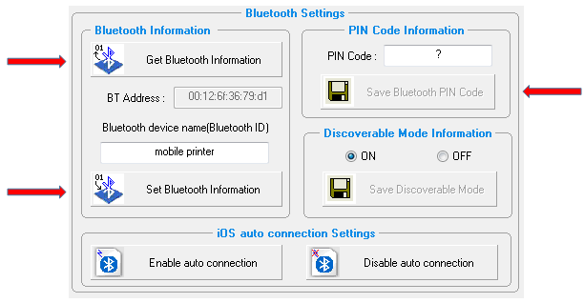
- [Wi-Fi ONLY] If the port is still open after completing steps 1 – 7 click Close Port. In the Wi-Fi Settings section click the Start WiFi Settings button. In the Port Information section ensure the correct port is displayed and click the Open Port button. If the connection is successful the Open Port button will be grayed out and the Close Port button will become active.
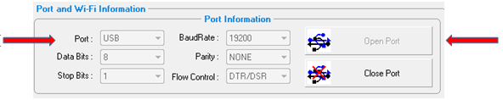
  - Click Get Wi-Fi Information button.
  - In the Wi-Fi Information section input the applicable Wi-Fi settings for your network.
  - Click the Save Wi-Fi Information button. Click OK in the confirmation pop-up. You will see that the IP settings are populated. The Wi-Fi icon in the printer will signal an active connection.
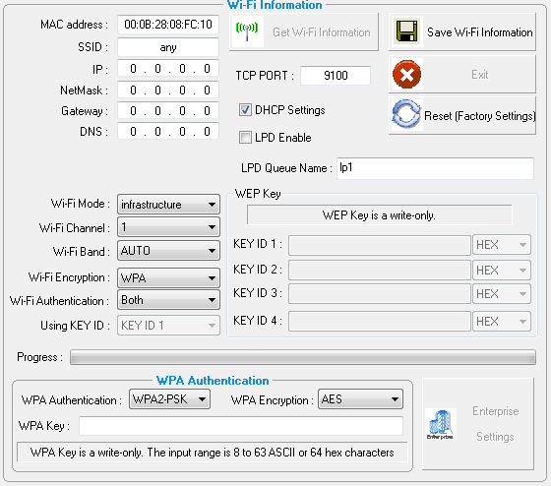
  - To Exit click Close Port in the Port Information section then click Exit. Click Exit again.

